MOTION PAST EXAM BOOKLET

Contents

Syllabus Points 3

Vectors - 6.1-6.4 4

2021 4

2016 4

2015 5

Mass vs Weight - 8.7 6

2018 6

2015 8

2019 10

2020 12

Graphing position, velocity and acceleration over time - 7.3 14

2015 14

2019 16

2020 18

2022 20

Equations for Uniform acceleration - 7.4 22

2017 22

2017 23

Vertical Motion – 7.5 24

2015 24

2016 26

2017 28

2018 29

2020 30

Inclined Planes 31

2022 31

Conservation of Momentum – 8.1 32

2020 32

Change in Momentum and Impulse – 8.2 33

2022 34

Newton's Second Law - 8.4 35

2016 35

2019 36

2017 COMPREHENSION 38

2021 COMPREHENSION 40

Newton’s Third Law – 8.5 43

2017 43

2019 44

2020 45

Impulse and Force - 8.6 47

2015 COMPREHENSION 47

Energy and Work - 9.1 51

2021 53

2022 53

2020 COMPREHENSION 54

2016 59

2017 60

2018 60

2021 61

Law of conservation of energy - 9.5 64

2020 64

Power 9.6 65

2016 65

2017 67

2018 67

2022 68

# Syllabus Points

# Vectors - 6.1-6.4

## 2021

## 2016

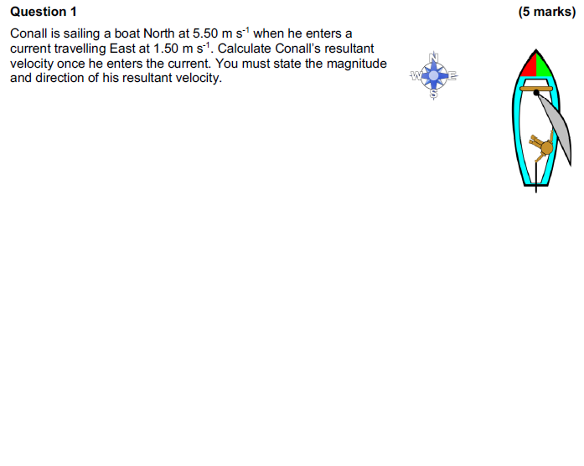

## 2015

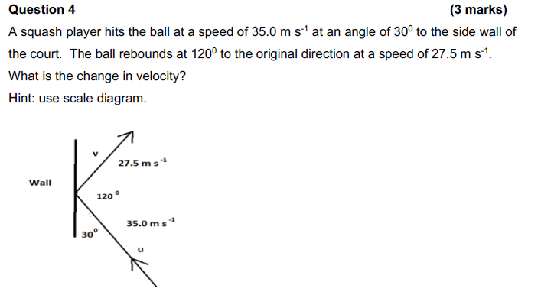

# Mass vs Weight - 8.7

## 2018

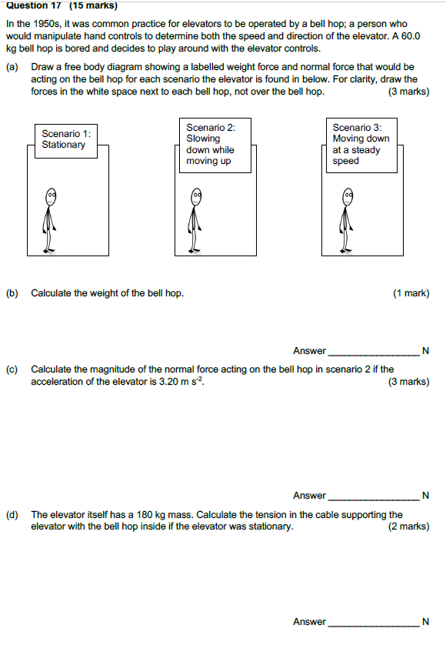

# Graphing position, velocity and acceleration over time - 7.3

## 2015

## 2019

## 2020

## 2022

# Equations for Uniform acceleration - 7.4

## 2017

## 2017

# Vertical Motion – 7.5

## 2015

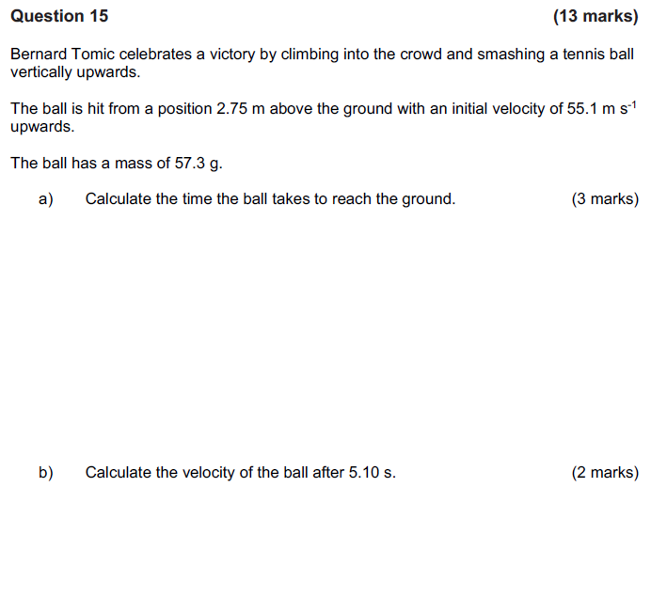

## 2016

## 2017

## 2018

## 2020

# Inclined Planes

## 2022

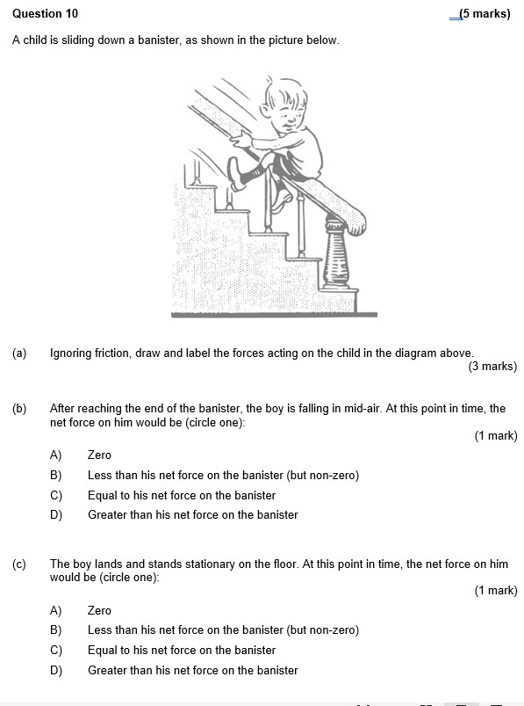

# Conservation of Momentum – 8.1

## 2020

# Change in Momentum and Impulse – 8.2

## 2022

# Newton's Second Law - 8.4

## 2016

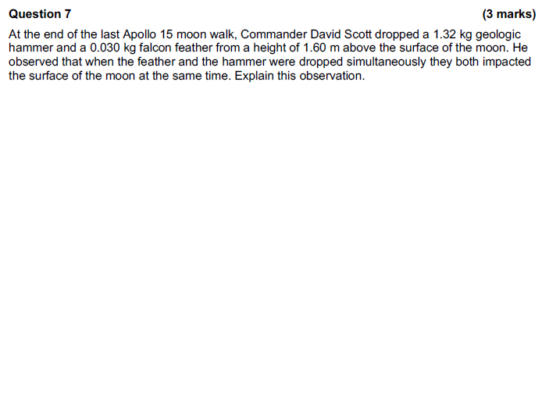  
2022

## 2019

## 2017 COMPREHENSION

## 2021 COMPREHENSION

# Newton’s Third Law – 8.5

## 2017

## 2019

## 2020

# Impulse and Force - 8.6

## 2015 COMPREHENSION

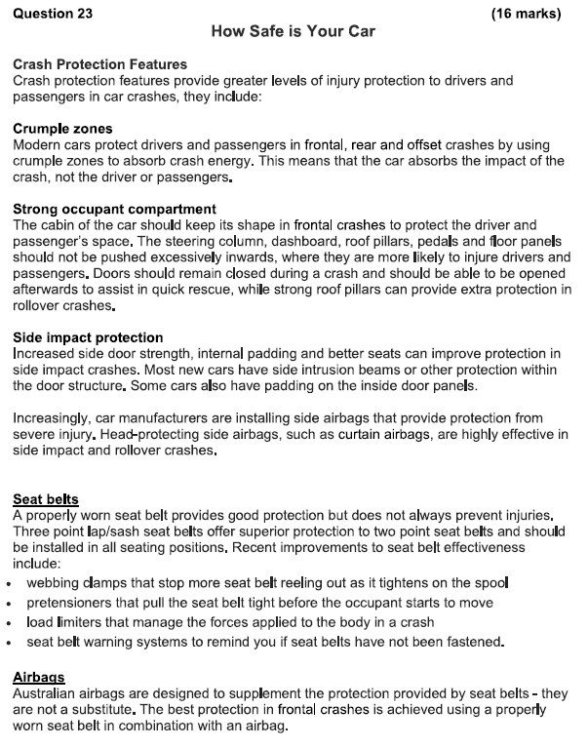

# Energy and Work - 9.1

## 2021

## 2022

## 2020 COMPREHENSION

**Question 19 (20 marks)**

**ELECTRIC POWER AND MECHANICAL WORK**

Some students performed an investigation to determine the efficiency of an electric motor as it converted electrical energy into mechanical work.

They used the rotation and torque produced by the motor to lift a 40.0 g mass through vertical distance of 35.0 cm. The electric power provided to the motor was increased and measured; the time taken for the mass to travel through this vertical distance was then determined.

The equipment used by the students is shown below:

Electric Motor

Pulley

Bench

Height Raised = 35.0 cm

Mass = 40.0 g

The students gradually increased the electric power provided to the motor by increasing the voltage on a power pack. They had performed an experiment prior to the investigation and determined that the average electric resistance of the motor was equal to 7.30 Ω. For each increased power, the average time for the mass to have its height increased by a distance of 35.0 cm was measured. The table below summarises the results obtained by the students.

|  |  |  |  |
| --- | --- | --- | --- |
| Voltage ‘V’ (V) | Time ‘t’ (s) | V2 (V2) | 1/t  (s-1) |
| 0.400 | 7.81 | 0.160 |  |
| 0.600 | 3.47 | 0.360 | 0.288 |
| 0.800 | 1.95 |  | 0.513 |
| 1.00 | 1.25 | 1.00 | 0.800 |
| 1.20 | 0.868 | 1.44 | 1.15 |

The students used this data to determine the efficiency of the motor ‘η’ (expressed as a decimal).

**BACKGROUND**

From their Physics classes, the students were aware of the following:

**Electric power supplied to the electric motor:**

**Gravitational potential energy (EP) supplied to the mass as it is raised through height ‘h’:**

**Power is the rate at which energy is added to the mass:**

In addition to the table of values provided previously, the students also had measured the following data:

|  |  |
| --- | --- |
| **Mass of the object being raised** | **40.0 g** |
| **Height through which the object is raised** | **35.0 cm** |
| **Electrical resistance of the electric motor** | **7.30 Ω** |
| **Acceleration due to gravity** | * 1. **s-2** |

1. By combining the appropriate expressions listed above, derive the following relationship:

Where: V = voltage supplied to the electric motor (V)

η = efficiency of the electric motor

t = time taken for 40.0 g mass to be raised 35.0 cm.

(4 marks)

1. Fill in the two missing values in the table. Any working can be shown below.

(2 marks)

The students decided to plot ‘V2’ values against ‘1/t’ values for their graphical analysis of the data.

1. Explain why the students chose this graphical approach. In addition, state an assumption that you made when choosing the graph.

(3 marks)

1. On the grid on the next page, plot ‘V2’ against ‘1/t’. Place the ‘V2’ values on the vertical axis. Draw a line of best fit for your data.

(4 marks)



1. Calculate the slope of the line of best fit you have drawn. Show clearly how you have done this. Include units in your answer.

(4 marks)

1. Use the slope you have calculated in part f) to determine the efficiency ‘η’ of the electric motor. Show clearly how you have done this.

(3 marks)

Elastic and Inelastic collisions - 9.3

## 2016

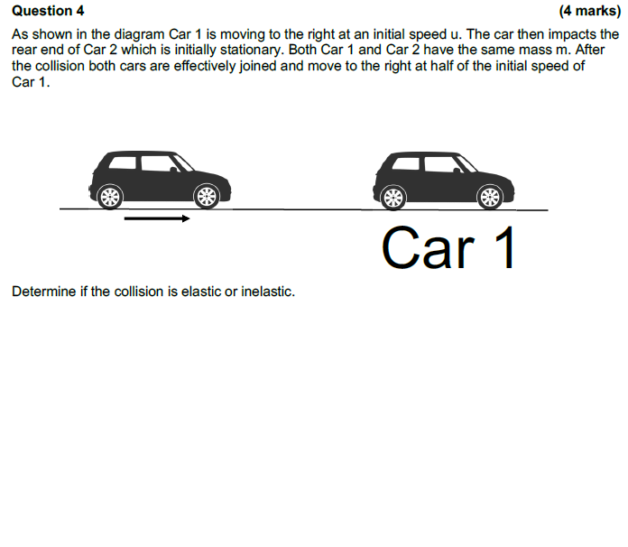

## 2017

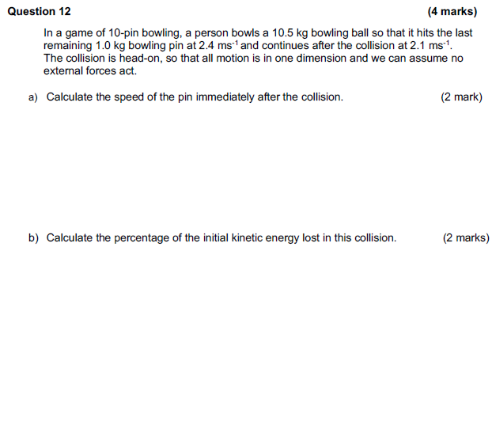

## 2018

## 2021

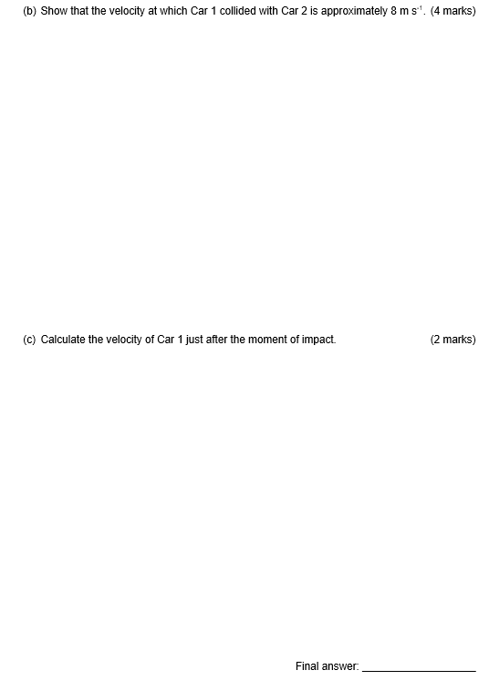

# Law of conservation of energy - 9.5

## 2020

# Power 9.6

## 2016

## 2017

## 2018

## 2022



